Regenerative Amendments

Vinegar Extraction

1 - Consider the life history of material used (gmo, pesticides, etc) before deciding whether to extract minerals from them.
2 - Bake at 350 to remove water and organic residue
3 - Mix in a glass jar: 10-15% material, 85-90% organic apple cider vinegar
4 - Decant after a week or 2 - repeat until no reaction occurs.
5 - Remains go to compost pile.
6 - Strain and store out of sun in well ventilated constant temperature space

Water Extraction

1 - Put plants in bucket with water, cover, and let sit
2 - For fist 2 or 3 days, strain and dilute 1:10 or up to 1:30 and apply to soil as a biologic inoculant
3 - After a week, the ph will drop and the liquid can be strained into jars and covered with a tight lid for future. You can allow decomposition to continue and then use as a mineral amendment after diluting it.

Fermented Plant Juice

1 - Pick plant material before sunrise when it is wet with dew - do not wash.
2 - Mix plant material with organic brown sugar.
3 - Fill glass jar; cover top of surface with sugar.
4 - Initiate fermentation by placing weight on top of contents, Cover with a cloth
5 - allow liquid to form until material is submerged, then remove weight. Store out of sunlight for I week.
6 - Strain liquid, using force of gravity only.
7 - use as foliar spray or drench, diluting with good water - start at 1:500 ratio. That would be 2 tablespoons of amendment to 4 gallons of water.

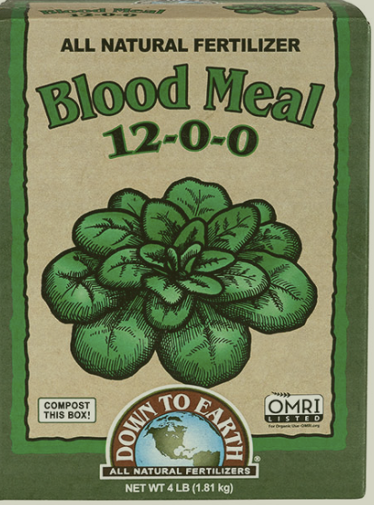


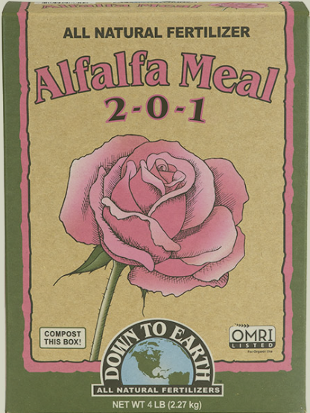
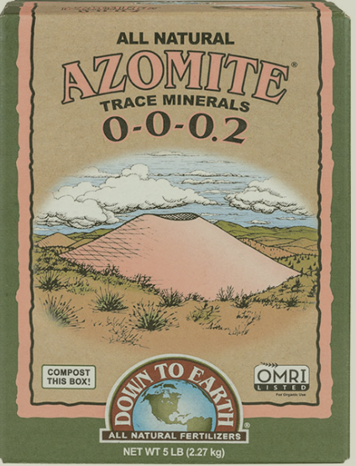


N - Nitrogen - leaf and stem growth - greening of plant
P- phosphorus - root development oand production of flowers and fruit
K - immune system, water balance and quality of fruit and plant

downtoearth.com
David Stack’s Urban Harvest

